Experiment: Implement Git Ignore
Objective
What is Git Ignore?
Git Ignore is a feature of Git that tells Git to ignore specific files or folders. Files listed in the .gitignore file are not tracked by Git and are not included in commits. It is mainly used to exclude temporary files, log files, build files, and other unnecessary files from the repository.
Why is .gitignore used?
Prevents unnecessary files from being committed.
Keeps the repository clean.
Avoids uploading temporary and log files.
Makes collaboration easier by excluding machine-specific files.

Commands Executed

1. Navigate to the Git project
cd /c/Users/laksh/source/repos/CTS_DotNET5.0/"Deep Skilling"/Git

2. Create a log file
echo "This is a log file" > sample.log

3. Create a log folder
mkdir log

4. Create a file inside the log folder
echo "Log data" > log/log1.txt

5. Check repository status
git status

6. Create .gitignore
notepad .gitignore
Add the following lines:
*.log
log/
Save the file.

7. Verify .gitignore
cat .gitignore

8. Check status again
git status
The sample.log file and log folder are ignored by Git.

9. Add .gitignore
git add .gitignore

10. Commit
git commit -m "Added .gitignore"

11. Push
git pull --rebase origin main
git push origin main

12. Verify
git status

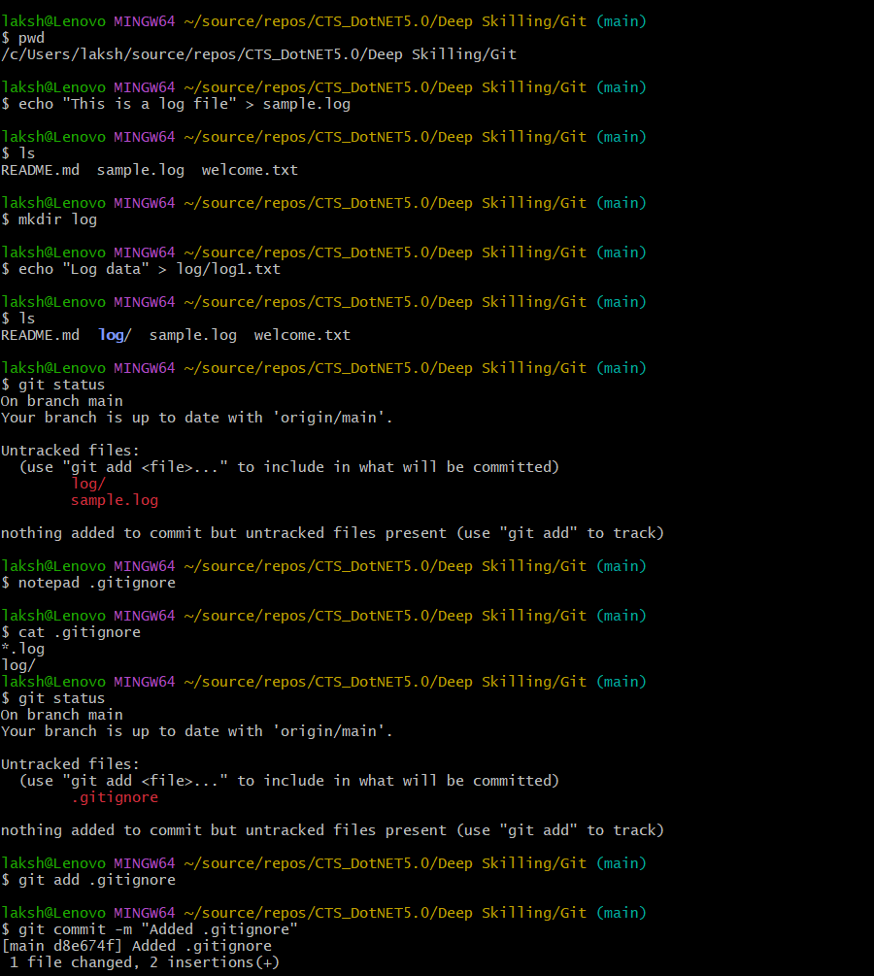
Outputs:
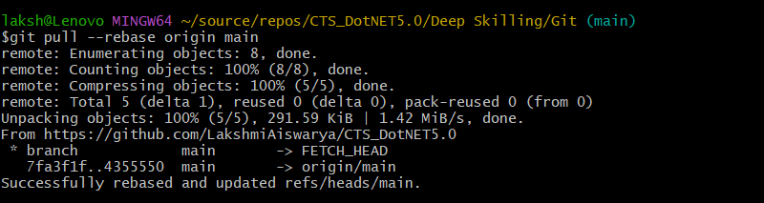
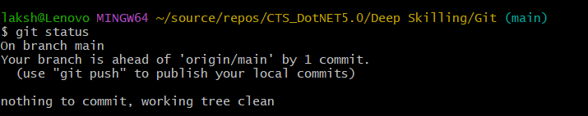
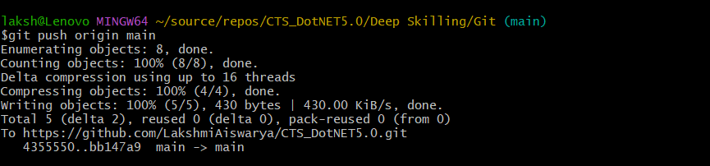

Result
The .gitignore file was successfully created and configured to ignore all .log files and the log folder. The ignored files were not tracked by Git, and the .gitignore file was committed and pushed successfully to the remote repository.

